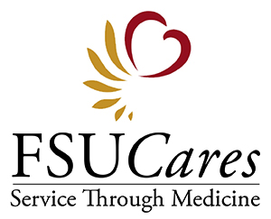
2014-2015 Executive Board
Staci Biegner, President
Sarah Hardy, Vice President
Rachel Johnson, Secretary
Kristen Nord, Treasurer
Kaitlin Nicholson, Events Coordinator
Carlos Rubiano, Service Learning Trips Coordinator

HOW TO MAKE YOUR CHARITABLE DONATION
Checks payable to FSU Foundation; place FSUCares in subject line:

FSU College of Medicine
c/o FSUCares
Box G108
Florida State University
College of Medicine
1115 W. Call Street
Tallahassee, FL 32306-4300
Online at:
www.one.fsu.edu
Click on Give Online
Click on the FSU Foundation button
Under the Donation Information section, please click on More Designations and search for FSUCares

Please return the section below via mail or email (fsucares@med.fsu.edu) so that the student or faculty member who solicited your donation can be properly acknowledged.

Individual or Business Name:

Mailing Address:

Email Address:

Donation Amount:

Please circle the fund to which you are donating: | General Fund  Immokalee Spring Break Trip  Panama Spring Break Trip  Chapman Community Health Program
Student or Faculty Contact:

Faculty Advisors
Kimberly Driscoll, Ph.D., Faculty Advisor
Ricardo Gonzalez-Rothi, M.D., Clinical Faculty Advisor
Karen Myers, ARPN, Community Outreach Liaison
Christie Alexander, M.D., Chapman Community Health Program Advisor
Andree Aubrey, MSW, LCSW, Smoking Cessation & Service Learning Liaison
Javier Rosado, Ph.D., Immokalee Faculty Liaison
Kenneth Brummel-Smith, M.D., Panama Faculty Liaison

